Lab Program 1:
Develop a Java program that prints all real solutions to the quadratic equation ax² +bx+c = 0. Read in a, b, c and use the quadratic formula. If the discriminate b²-4ac is negative, display a message stating that there are no real solutions.

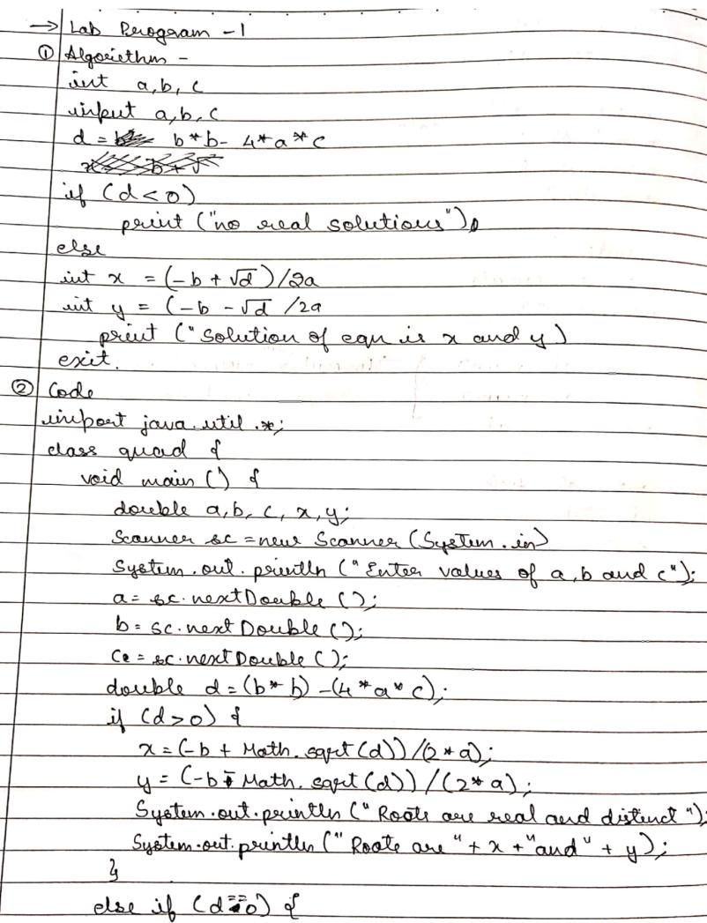
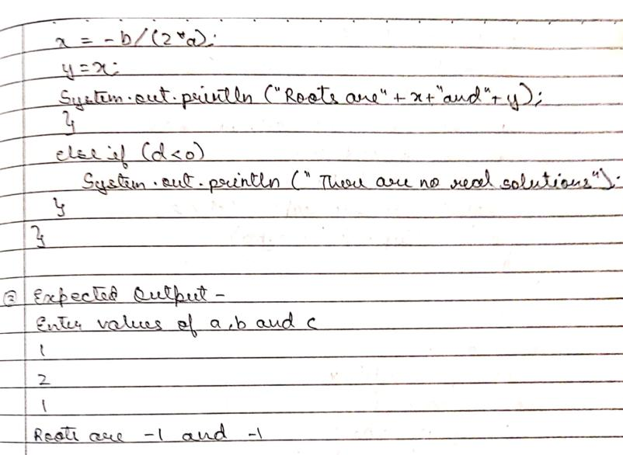

Output-
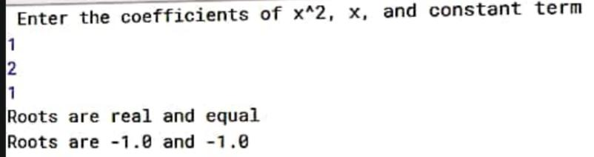

Lab Program 2:

Develop a Java program to create a class Student with members usn, name, an array credits and an array marks. Include methods to accept and display details and a method to calculate SGPA of a student.

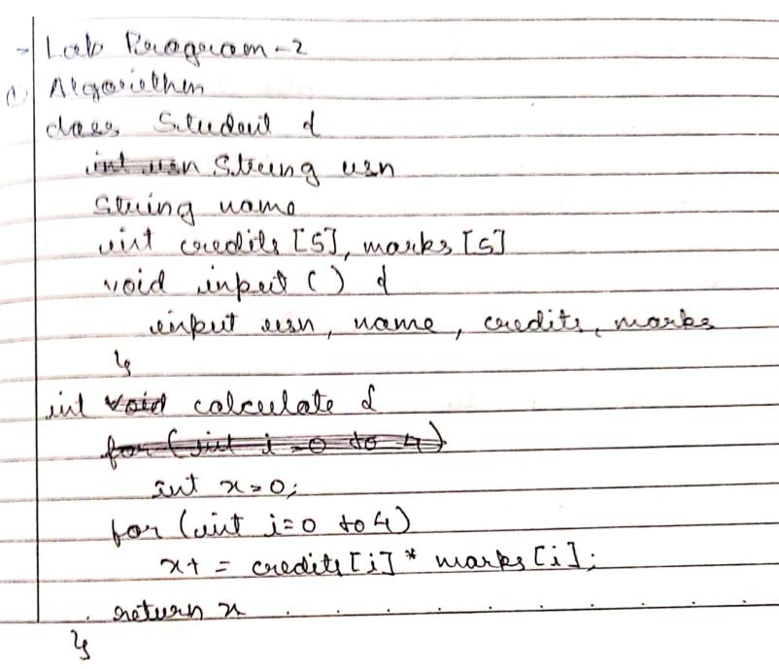
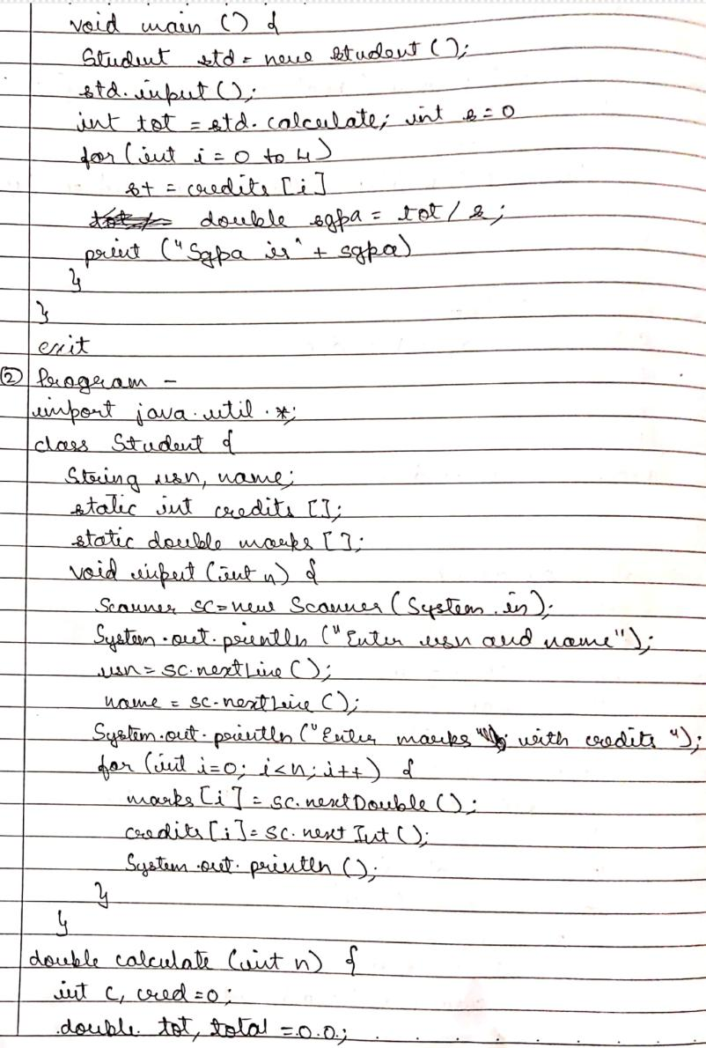

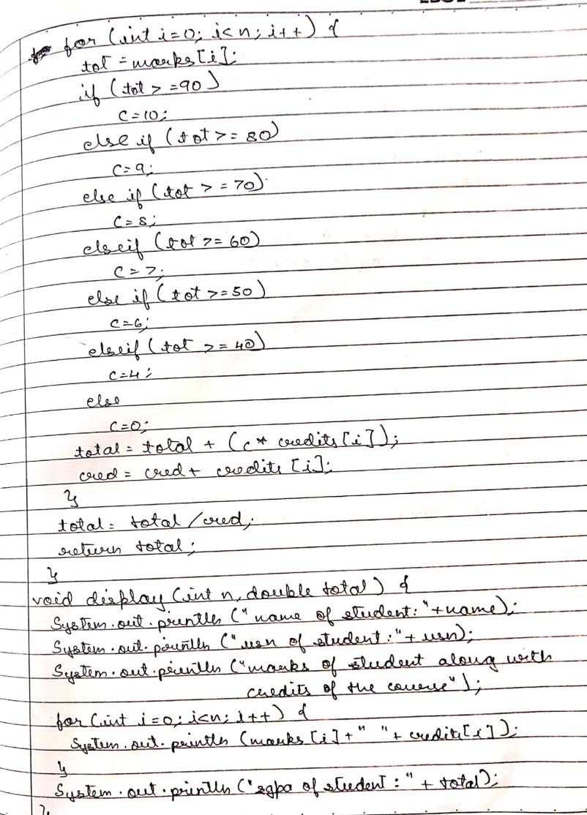

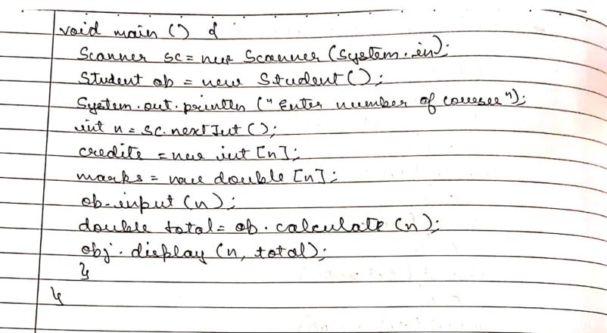Output-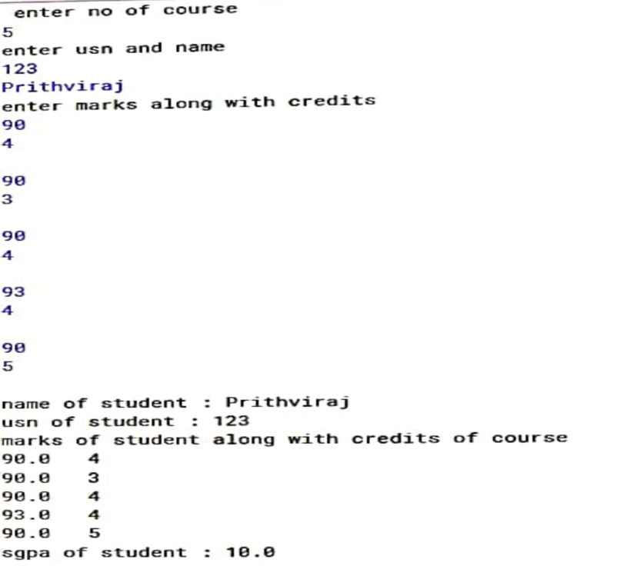
Lab Program - 3
Create a class Book which contains four members: name, author, price, num_pages. Include a constructor to set the values for the members. Include methods to set and get the details of the objects. Include a toString( ) method that could display the complete details of the book. Develop a Java program to create n book objects.
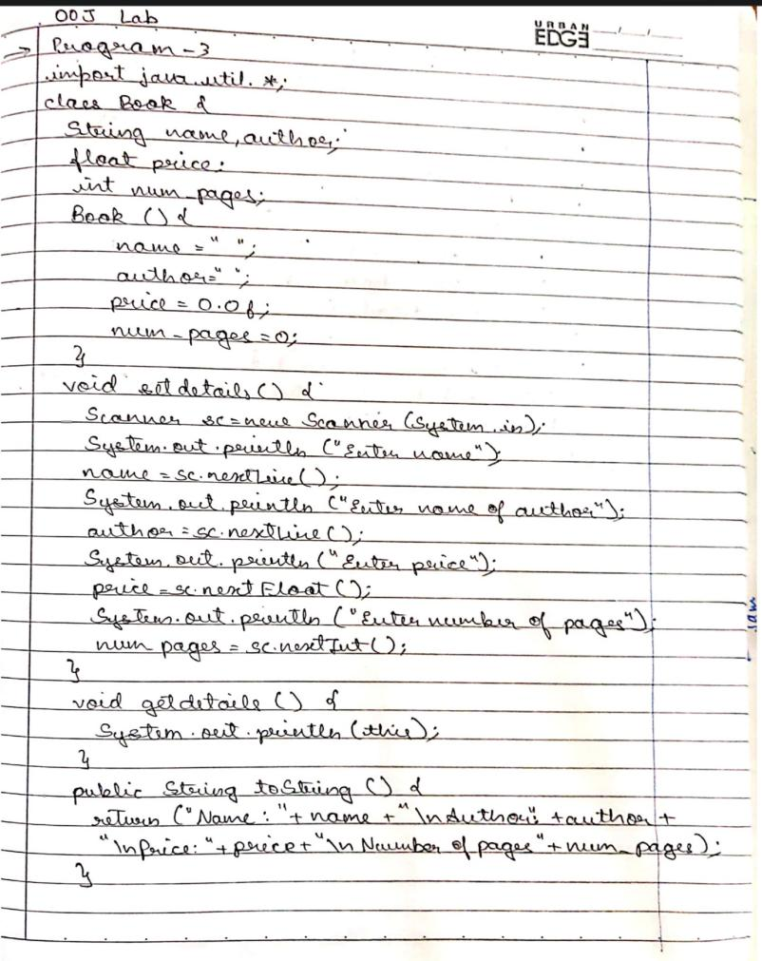
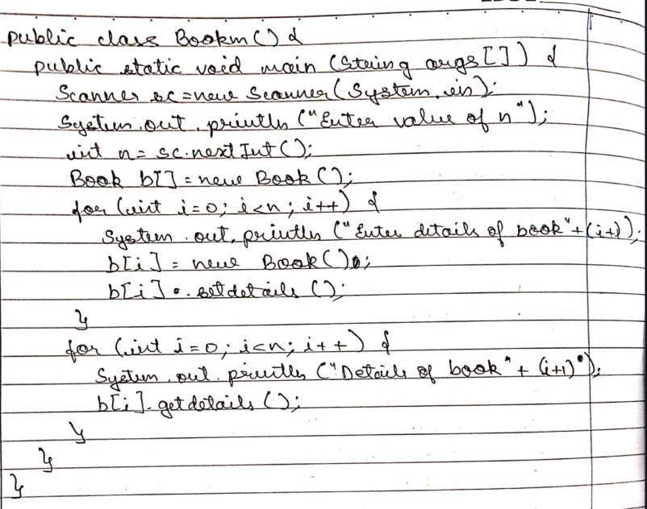

Output-

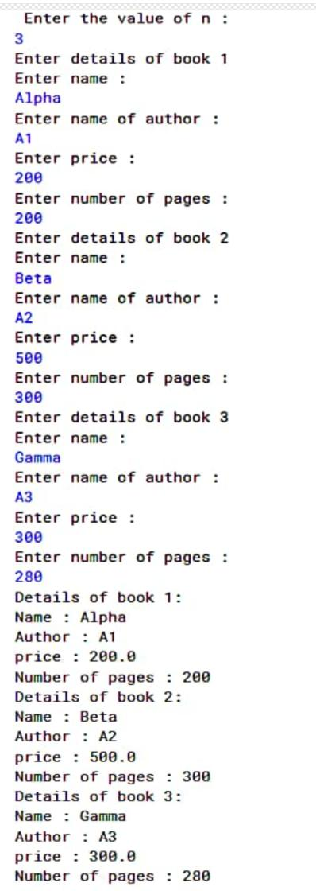
Lab Program 4:
Develop a Java program to create an abstract class named Shape that contains two integers and an empty method named printArea(). Provide three classes named Rectangle, Triangle and Circle such that each one of the classes extends the class Shape. Each one of the classes contain only the method printArea( ) that prints the area of the given shape.
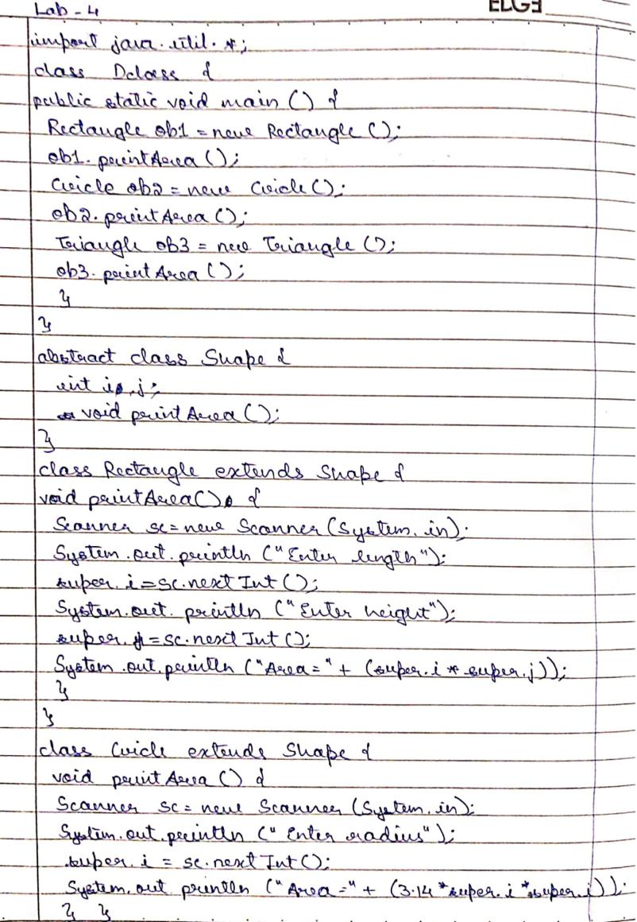
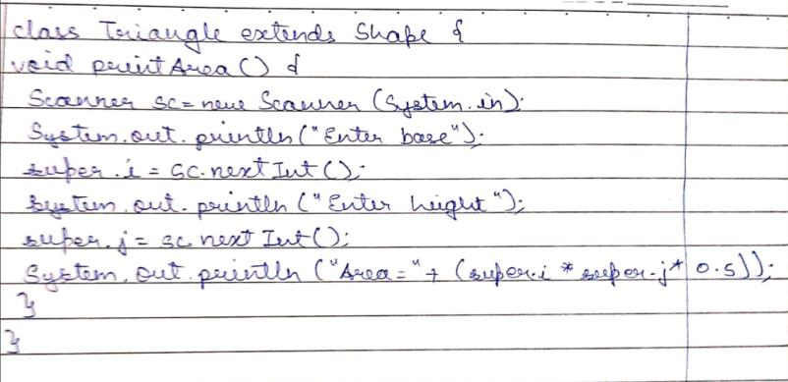

Output:

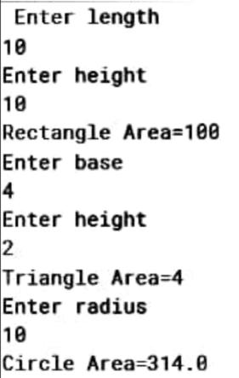

Lab Program 5:
Develop a Java program to create a class Bank that maintains two kinds of account for its customers, one called savings account and the other current account. The savings account provides compound interest and withdrawal facilities but no cheque book facility. The current account provides cheque book facility but no interest. Current account holders should also maintain a minimum balance and if the balance falls below this level, a service charge is imposed. Create a class Account that stores customer name, account number and type of account. From this derive the classes Curr-acct and Sav-acct to make them more specific to their requirements. Include the necessary methods in order to achieve the following tasks: • Accept deposit from customer and update the balance. • Display the balance. • Compute and deposit interest • Permit withdrawal and update the balance • Check for the minimum balance, impose penalty if necessary and update the balance
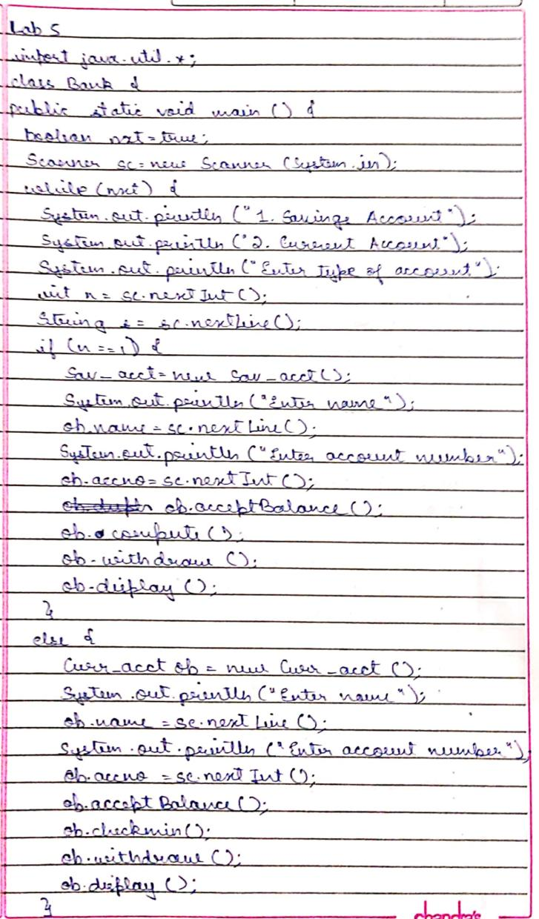
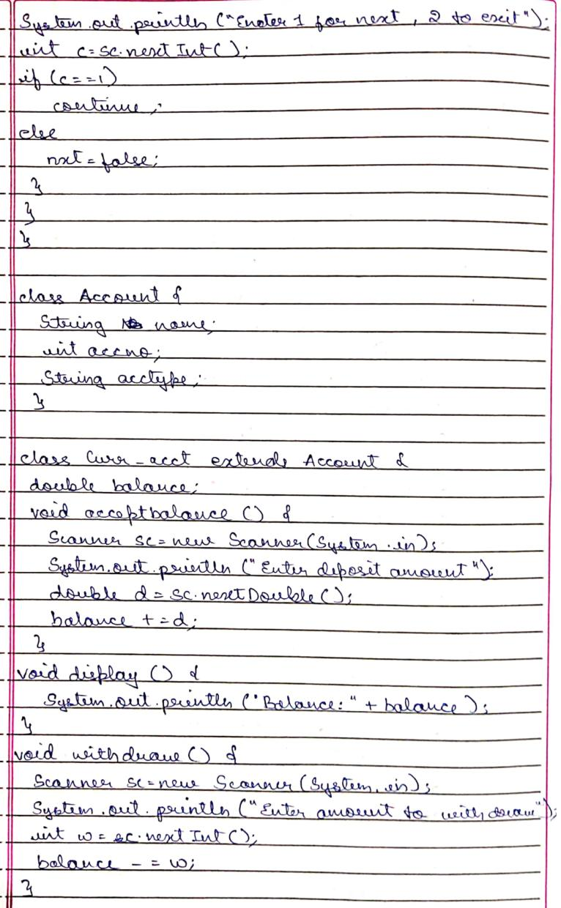
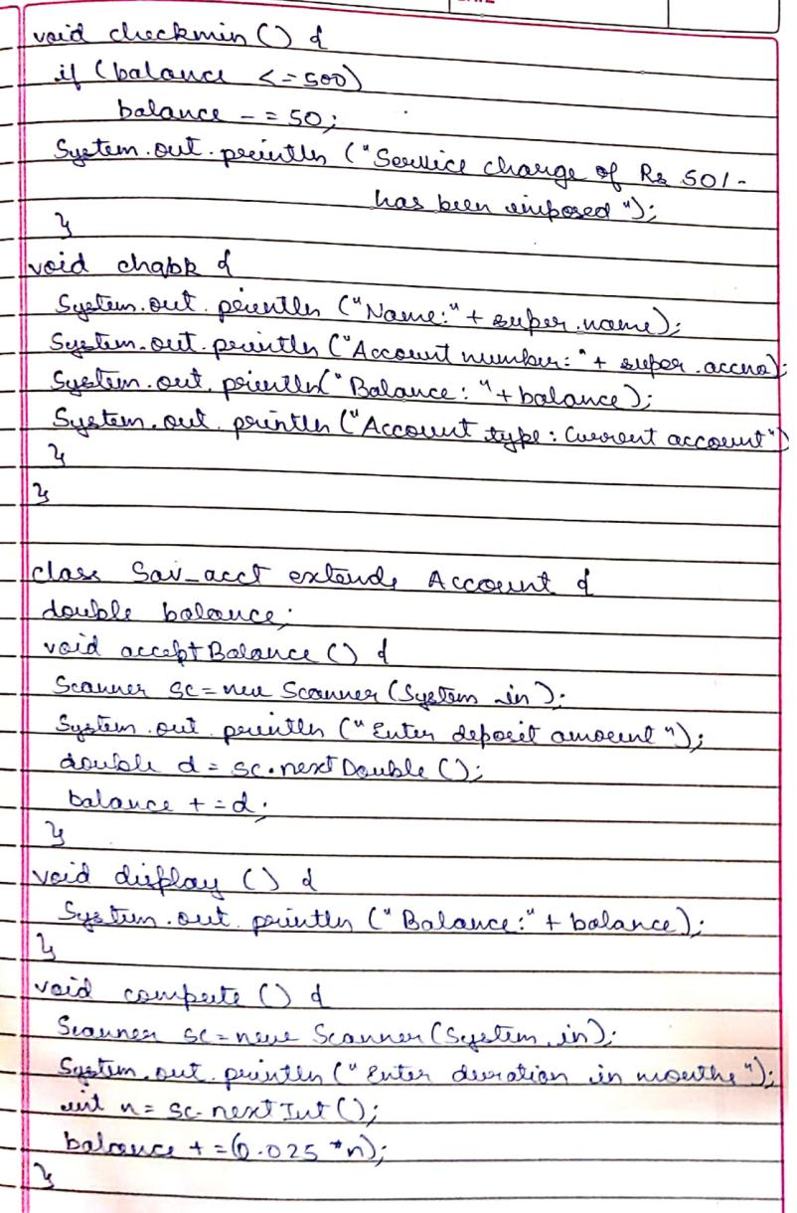
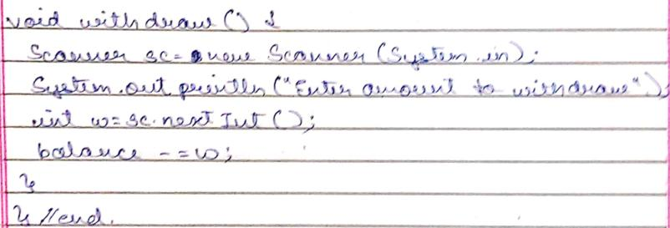
Output:
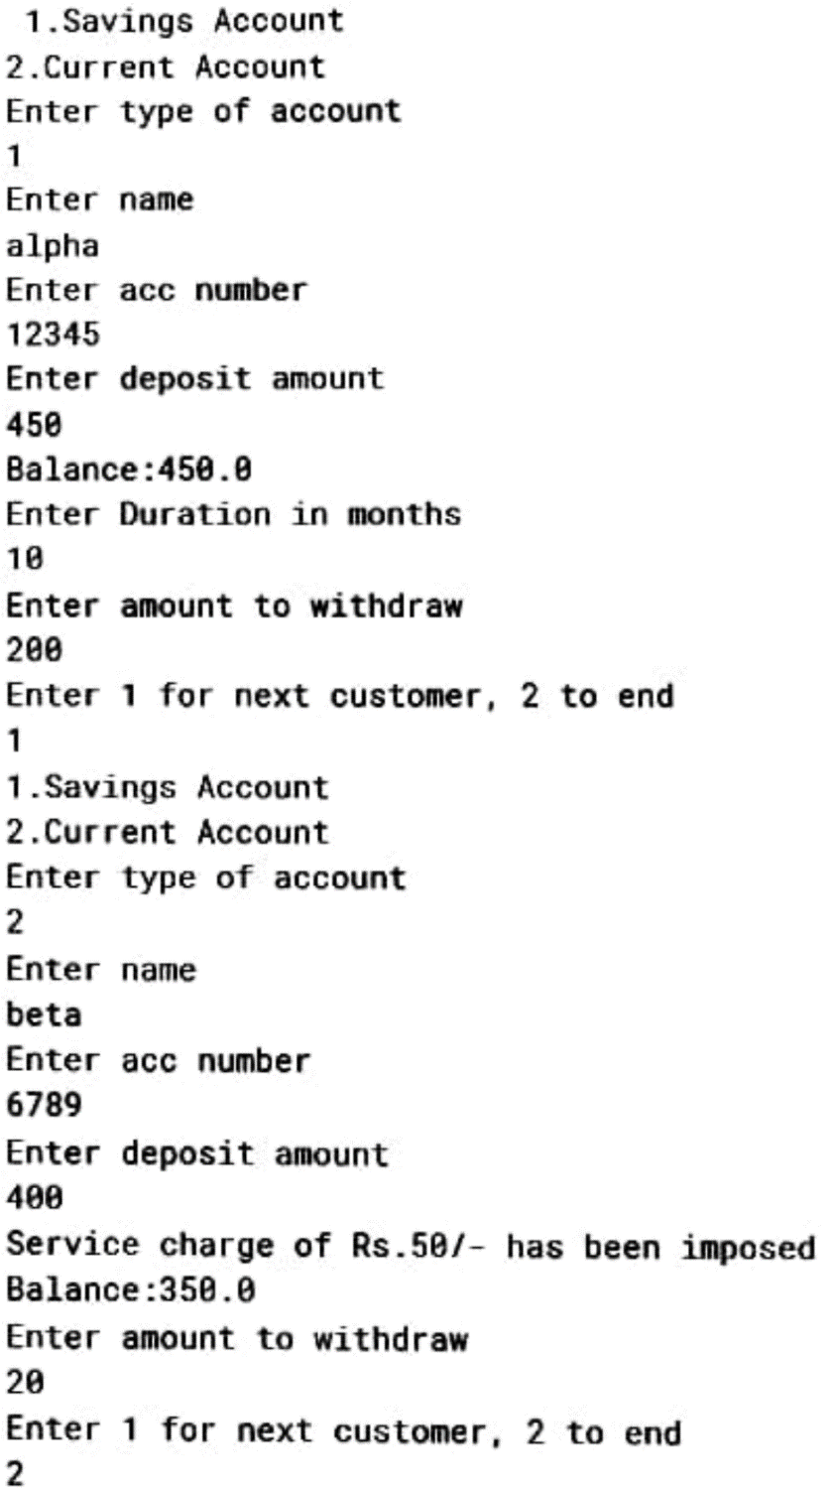
Lab Program-6:
Create a package CIE which has two classes- Student and Internals. The class Personal has members like usn, name, sem. The class Internals has an array that stores the internal marks scored in five courses of the current semester of the student. Create another package SEE which has the class External which is a derived class of Student. This class has an array that stores the SEE marks scored in five courses of the current semester of the student. Import the two packages in a file that declares the final marks of n students in all five courses.
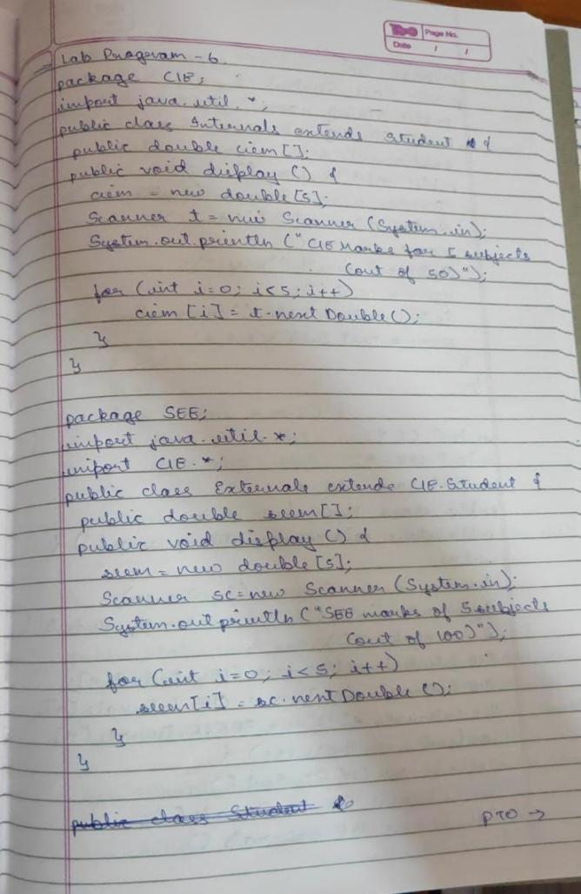
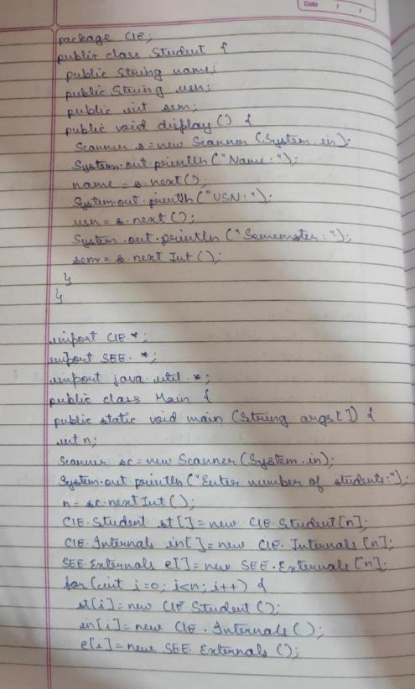
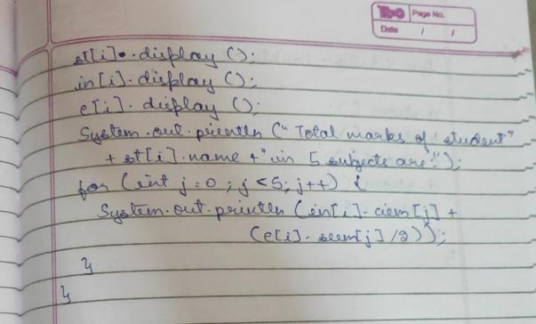
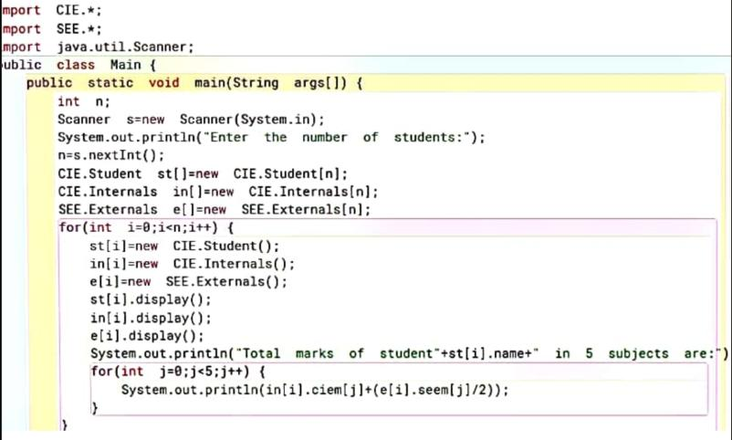
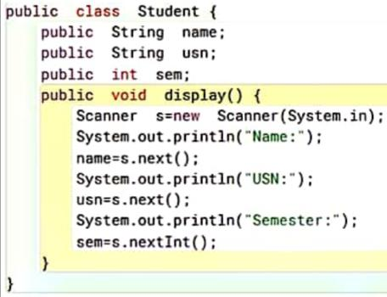
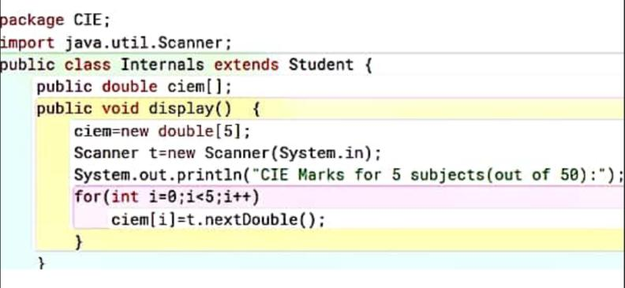
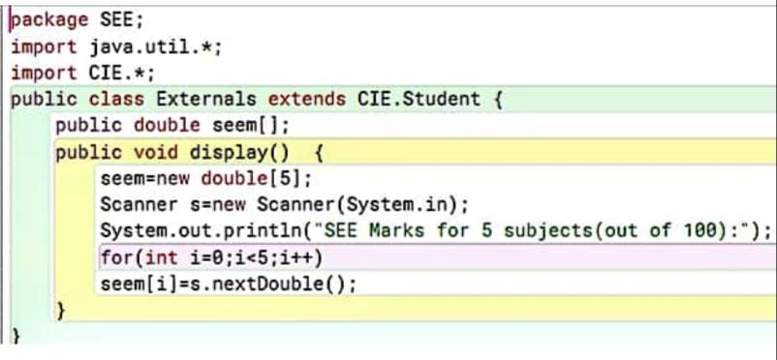
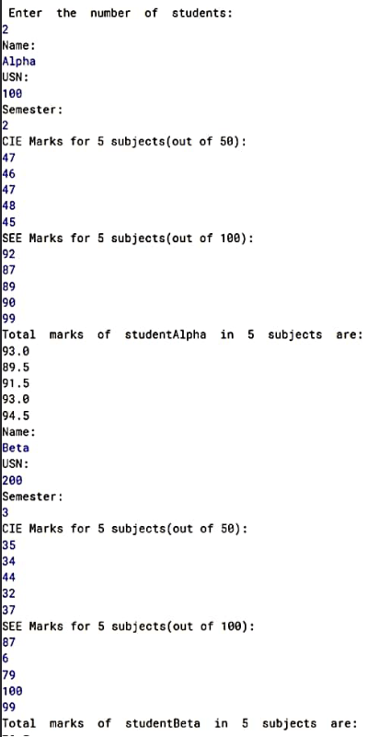
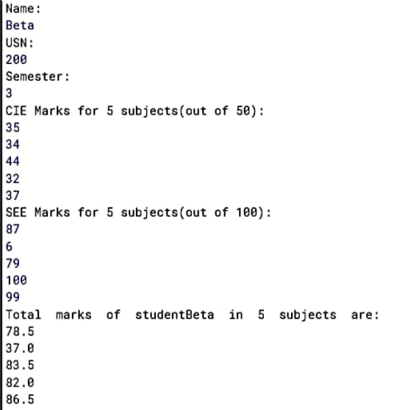

Lab Program-7:
Write a program to demonstrate generics with multiple object parameters.
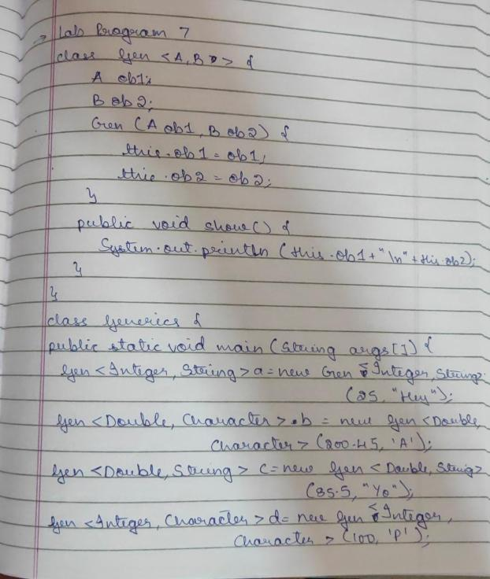
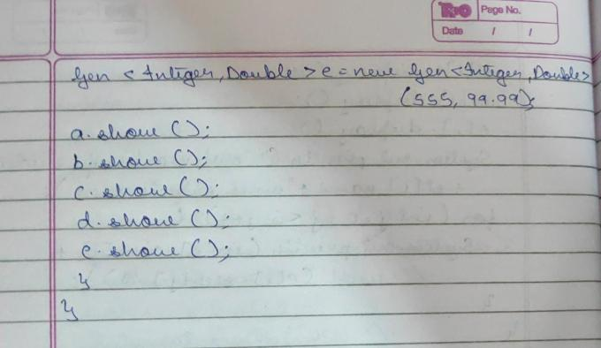
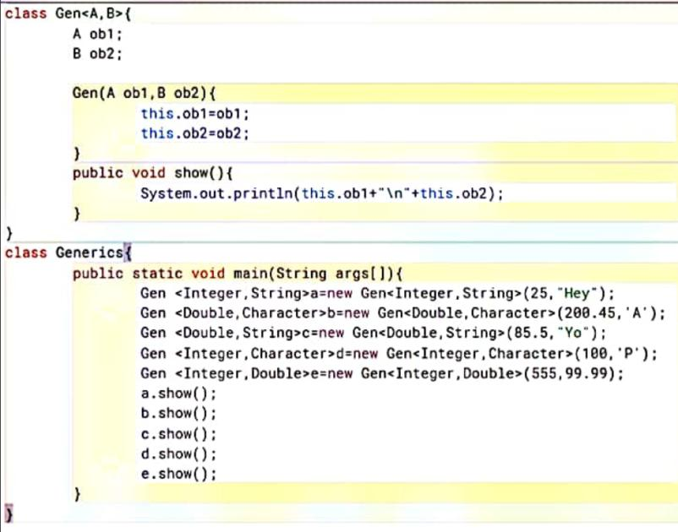
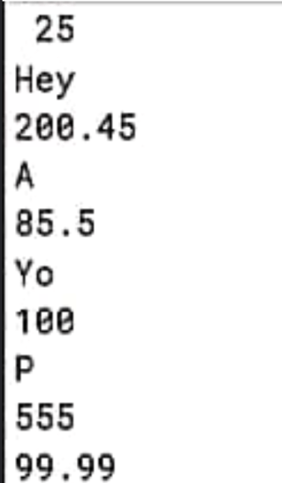
Lab Program-8:
Write a program that demonstrates handling of exceptions in inheritance tree. Create a base class called “Father” and derived class called “Son” which extends the base class. In Father class, implement a constructor which takes the age and throws the exception WrongAge( ) when the input age<0. In Son class, implement a constructor that cases both father and son’s age and throws an exception if son’s age is >=father’s age.
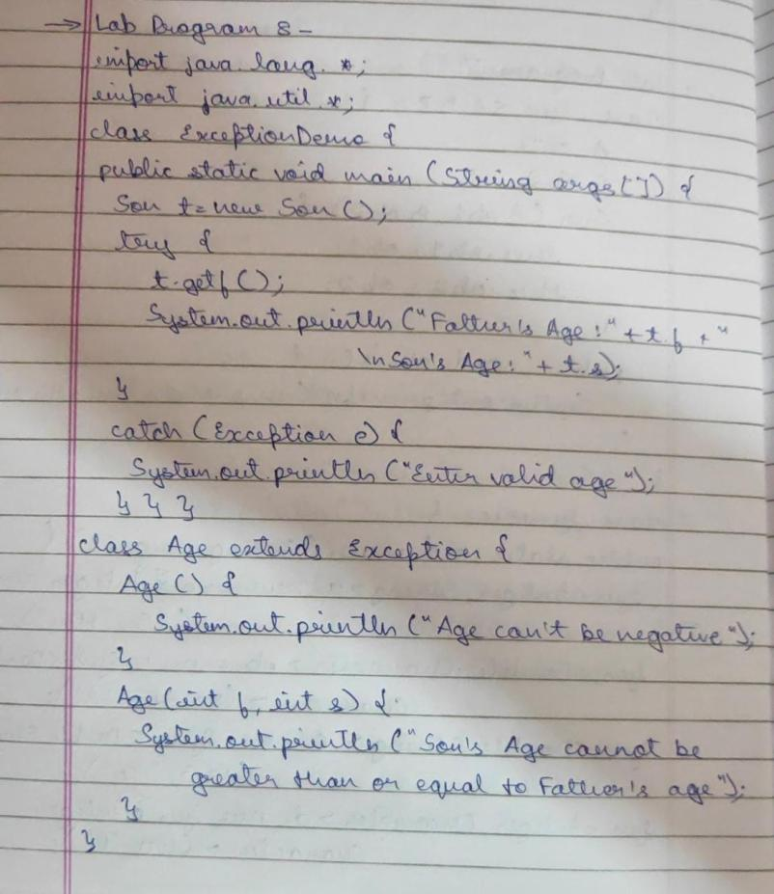

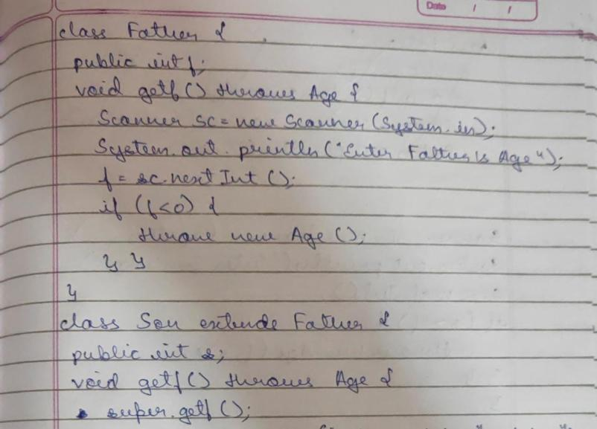

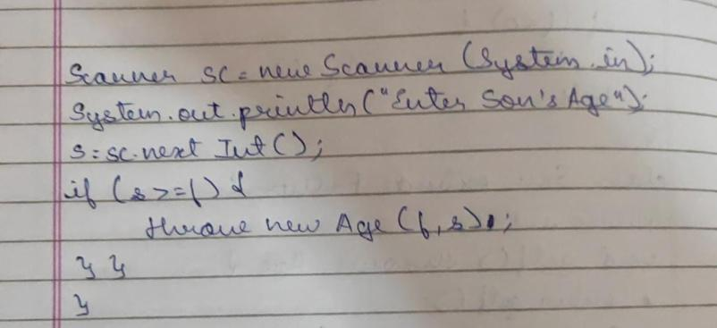
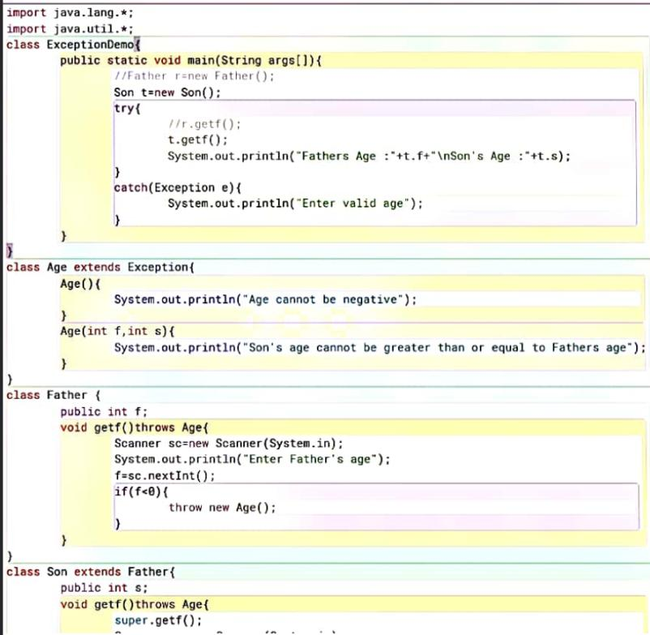
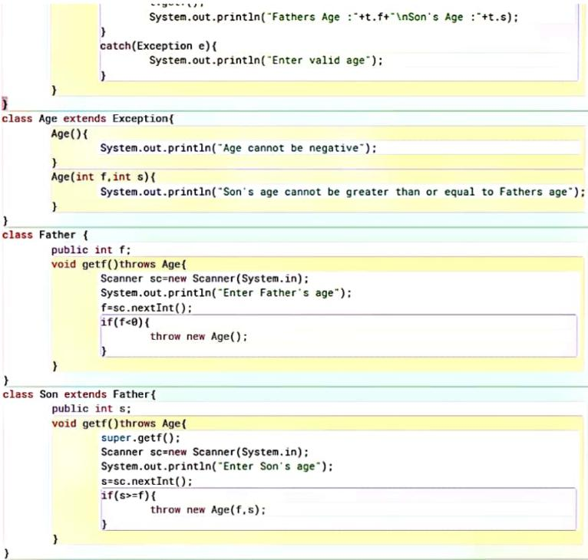
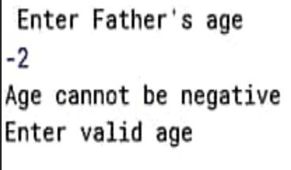
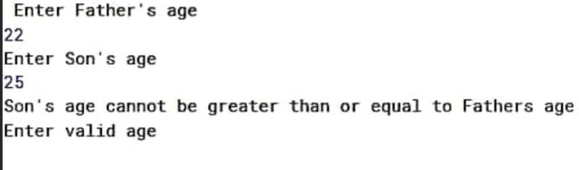
Lab Program-9:
Write a program which creates two threads, one thread displaying “BMS College of Engineering” once every ten seconds and another displaying “CSE” once every two seconds.
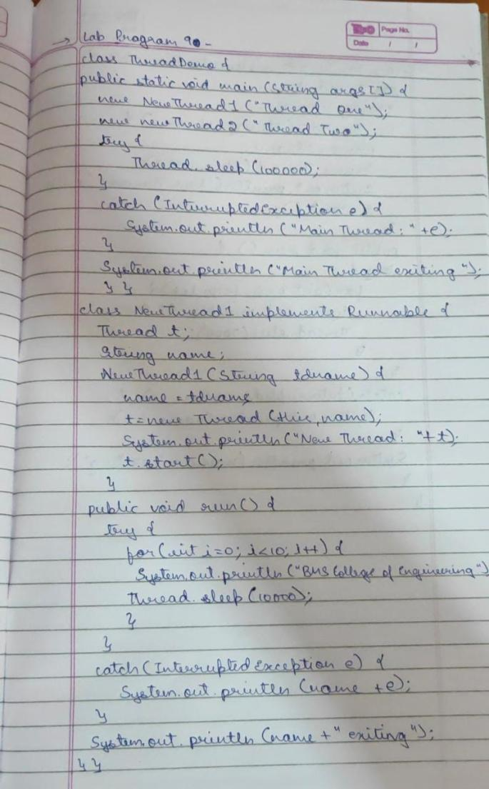
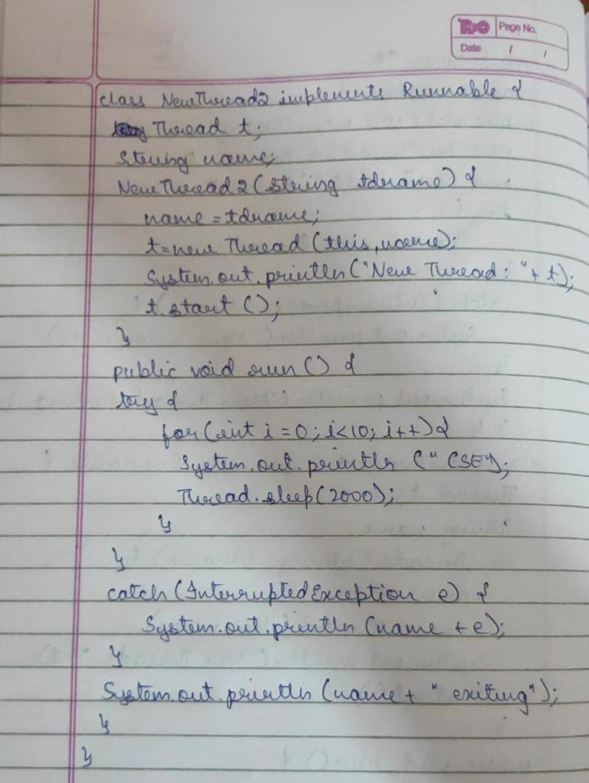
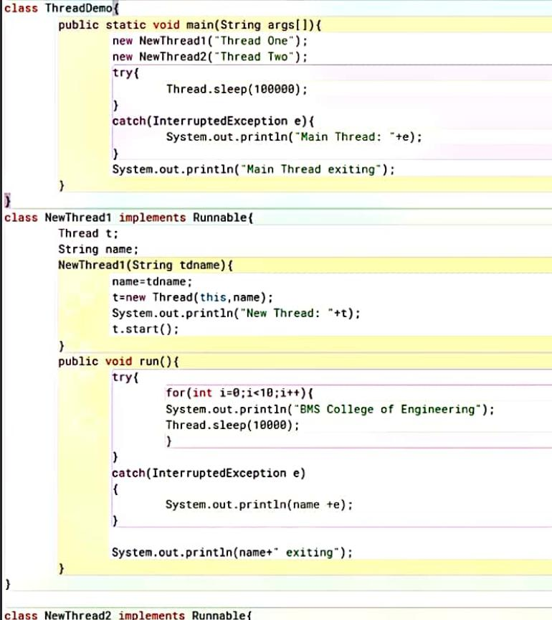

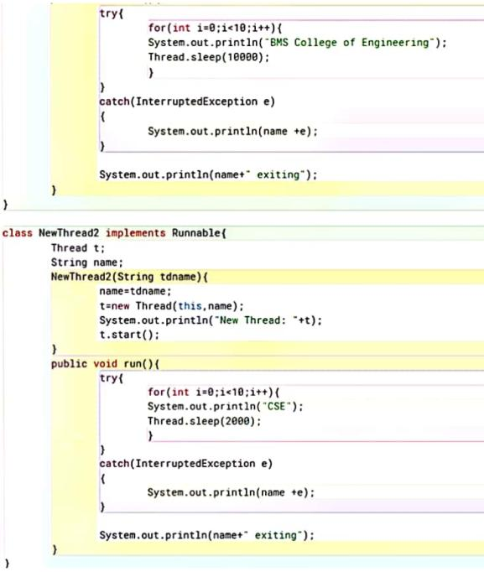
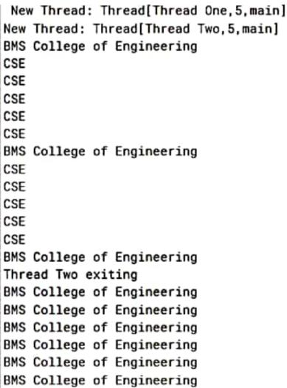
Lab Program-10:
Write a program that creates a user interface to perform integer divisions. The user enters two numbers in the text fields, Num1 and Num2. The division of Num1 and Num2 is displayed in the Result field when the Divide button is clicked. If Num1 or Num2 were not an integer, the program would throw a NumberFormatException. If Num2 were Zero, the program would throw an Arithmetic Exception Display the exception in a message dialog box.
